Contents

Sprint 1 2

Unit Testing 2

Summary of JUnit 5 Test files 2

Results 2

Front End Testing 3

Test Case Results and Screenshots 3

Sprint 2 15

Unit Testing 15

Summary of JUnit 5 Test files 15

Results 15

Front End Testing 16

# Sprint 1

## Unit Testing

### Summary of JUnit 5 Test files

|  |  |
| --- | --- |
| Test Case File Name | Purpose |
| StaffTest.java | To test the functions inside the Staff class |

### Results

**StaffTest**

|  |  |  |  |
| --- | --- | --- | --- |
| Test ID | Test Case | Expected Result | Actual Result |
| Staff_1 | Login with valid User Admin credentials | True | True |
| Staff_2 | Login with invalid User Admin credentials | False | False |
| Staff_3 | Login with valid User Admin but wrong profile | False | False |
|  | | | |
| Staff_4 | Login with valid Manager credentials | True | True |
| Staff_5 | Login with invalid Manager credentials | False | False |
| Staff_6 | Login with valid Manager but wrong profile | False | False |
|  |  |  |  |
| Staff_7 | Login with valid Staff credentials | True | True |
| Staff_8 | Login with invalid Staff credentials | False | False |
| Staff_9 | Login with valid Staff but wrong profile | False | False |
|  | | | |
| Staff_10 | Login with valid Owner credentials | True | True |
| Staff_11 | Login with invalid Owner credentials | False | False |
| Staff_12 | Login with valid Owner but wrong profile | False | False |
|  | | | |
| Staff_13 | Create database connection object | True | True |

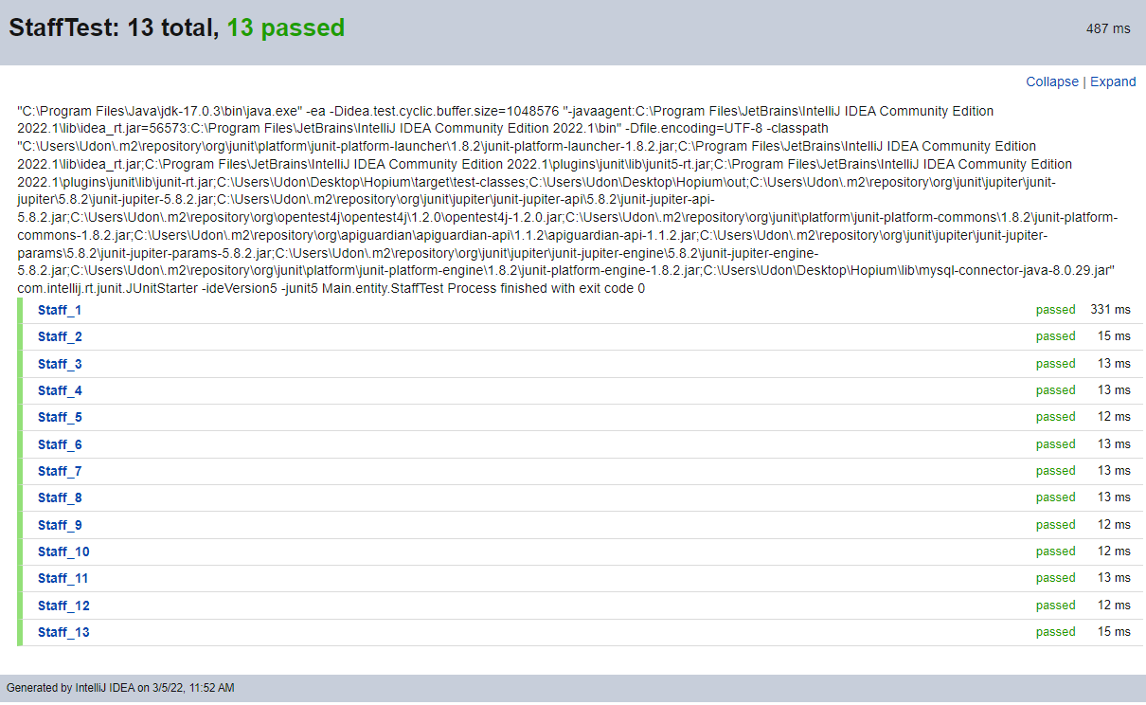

Staff Class Junit 5 output

## Front End Testing

### Test Case Results and Screenshots

#### User Story #1

|  |  |
| --- | --- |
| **Test Case 1.1 – Login with valid User Admin credentials** | |
| **Steps** | 1. Start application 2. Click ‘Staff’ button 3. Type in valid credentials (user_admin1 for both fields) 4. Select ‘User Admin’ in profile dropdown menu 5. Click ‘Login’ button |
| **Expected Results** | Logged in and User Admin homepage displayed |
| **Actual Results** | Logged in and User Admin homepage displayed |
| **Test Case 1.2 – Login with invalid User Admin credentials** | |
| **Steps** | 1. Start application 2. Click ‘Staff’ button 3. Type in invalid credentials (user_admin0 for both fields) 4. Select ‘User Admin’ in profile dropdown menu 5. Click ‘Login’ button |
| **Expected Results** | Failed Login |
| **Actual Results** | Failed Login |
| **Test Case 1.3 – Login with valid User Admin credentials but wrong profile** | |
| **Steps** | 1. Start application 2. Click ‘Staff’ button 3. Type in valid credentials (user_admin1 for both fields) 4. Select wrong profile in the profile dropdown menu (Restaurant Manager selected) 5. Click ‘Login’ button |
| **Expected Results** | Failed Login |
| **Actual Results** | Failed Login |

|  |  |
| --- | --- |
| Screenshots for User Story #1 | |
| Login page with valid credentials | Login page with invalid credentials |
| Error message with invalid credentials | User admin homepage after login |

#### User Story #2

|  |  |
| --- | --- |
| **Test Case 2.1 – Log out from the User Admin account** | |
| **Steps** | 1. While in the User Admin homepage, click the log out button |
| **Expected Results** | Logged out and returned to the login page |
| **Actual Results** | Logged out and returned to login page |

|  |  |
| --- | --- |
| Screenshots for User Story #2 | |
| Pressing Logout from homepage | Returned to login page |

#### User Story #13

|  |  |
| --- | --- |
| **Test Case 13.1 – Login with valid Restaurant Manager credentials** | |
| **Steps** | 1. Start Application 2. Click 'Staff' button 3. Type in valid username and password (manager1 for both fields) 4. Select Restaurant Manager in the profile login dropdown menu 5. Click 'Login' button |
| **Expected Results** | Logged in and Restaurant Manager homepage displayed |
| **Actual Results** | Logged in and Restaurant Manager homepage displayed |
| **Test Case 13.2 – Login with invalid Restaurant Manager credentials** | |
| **Steps** | 1. Start Application 2. Click 'Staff' button 3. Type in invalid username and password (manager0 for both fields) 4. Select Restaurant Manager in the profile login dropdown menu 5. Click 'Login' button |
| **Expected Results** | Failed Login |
| **Actual Results** | Failed Login |
| **Test Case 13.3 – Login with valid Restaurant Manager credentials but wrong profile** | |
| **Steps** | 1. Start Application 2. Click 'Staff' button 3. Type in valid username and password (manager1 for both fields) 4. Select wrong profile in the profile login dropdown menu (User Admin selected) 5. Click 'Login' button |
| **Expected Results** | Failed Login |
| **Actual Results** | Failed Login |

|  |  |
| --- | --- |
| Screenshots for User Story #13 | |
| Login page with valid credentials | Login page with invalid credentials |
| Error message with invalid credentials | Restaurant Manager homepage after login |

#### User Story #14

|  |  |
| --- | --- |
| **Test Case 14.1 – Log out from the Restaurant Manager account** | |
| **Steps** | 1. While in the Restaurant Manager homepage, click the log out button |
| **Expected Results** | Logged out and returned to the login page |

|  |  |
| --- | --- |
| Screenshots for User Story #14 | |
| Pressing Logout from homepage | Returned to login page |

#### User Story #20

|  |  |
| --- | --- |
| **Test Case 20.1 – Login with valid Restaurant Staff credentials** | |
| **Steps** | 1. Start application 2. Click ‘Staff’ button 3. Type in valid credentials (user1 for both fields) 4. Select ‘Restaurant Staff’ in profile dropdown menu 5. Click ‘Login’ button |
| **Expected Results** | Logged in and Restaurant Staff homepage displayed |
| **Actual Results** | Logged in and Restaurant Staff homepage displayed |
| **Test Case 20.2 – Login with invalid Restaurant Staff credentials** | |
| **Steps** | 1. Start application 2. Click ‘Staff’ button 3. Type in invalid credentials (user0 for both fields) 4. Select ‘Restaurant Staff’ in profile dropdown menu 5. Click ‘Login’ button |
| **Expected Results** | Failed Login |
| **Actual Results** | Failed Login |
| **Test Case 20.3 – Login with valid Restaurant Staff credentials but wrong profile** | |
| **Steps** | 1. Start application 2. Click ‘Staff’ button 3. Type in valid credentials (user1 for both fields) 4. Select wrong profile in the profile dropdown menu (User Admin selected) 5. Click ‘Login’ button |
| **Expected Results** | Failed Login |
| **Actual Results** | Failed Login |

|  |  |
| --- | --- |
| Screenshots for User Story #20 | |
| Login page with valid credentials | Login page with invalid credentials |
| Error message with invalid credentials | Restaurant Manager homepage after login |

#### User Story #21

|  |  |
| --- | --- |
| **Test Case 21.1 – Log out from the Restaurant Staff account** | |
| **Steps** | 1. While in the Restaurant Staff homepage, click the log out button |
| **Expected Results** | Logged out and returned to the login page |

|  |  |
| --- | --- |
| Screenshots for User Story #21 | |
| Pressing Logout from homepage | Returned to login page |

#### User Story #35

|  |  |
| --- | --- |
| **Test Case 35.1 – Login with valid credentials** | |
| **Steps** | 1. Start application 2. Click ‘Staff’ button 3. Type in valid credentials (owner1 for both fields) 4. Select ‘Restaurant Owner’ in profile dropdown menu 5. Click ‘Login’ button |
| **Expected Results** | Logged in and Restaurant Owner homepage displayed |
| **Actual Results** | Logged in and Restaurant Owner homepage displayed |

|  |  |
| --- | --- |
| **Test Case 35.2 – Login with invalid credentials** | |
| **Steps** | 1. Start application 2. Click ‘Staff’ button 3. Type in invalid credentials (owner0 for both fields) 4. Select ‘Restaurant Owner’ in profile dropdown menu 5. Click ‘Login’ button |
| **Expected Results** | Failed Login |
| **Actual Results** | Failed Login |

|  |  |
| --- | --- |
| **Test Case 35.3 – Login with valid credentials but wrong profile** | |
| **Steps** | 1. Start application 2. Click ‘Staff’ button 3. Type in valid credentials (owner1 for both fields) 4. Select wrong profile in the profile dropdown menu (User Admin selected) 5. Click ‘Login’ button |
| **Expected Results** | Failed Login |
| **Actual Results** | Failed Login |

|  |  |
| --- | --- |
| Screenshots for User Story #35 | |
| Login page with valid credentials | Login page with invalid credentials |
| Error message with invalid credentials | Restaurant Owner homepage after login |

#### User Story #36

|  |  |
| --- | --- |
| **Test Case 36.1 – Log out from the Restaurant Owner account** | |
| **Steps** | 1. While in the Restaurant Owner homepage, click the log out button |
| **Expected Results** | Logged out and returned to the login page |
| **Actual Results** | Logged out and returned to the login page |

|  |  |
| --- | --- |
| Screenshots for User Story #36 | |
| Pressing Logout from homepage | Returned to login page |

# Sprint 2

## Unit Testing

### Summary of JUnit 5 Test files

|  |  |
| --- | --- |
| Test Case File Name | Purpose |
| StaffTest.java | To test the functions inside the Staff class |
| User_Admin.java | To test the functions inside the User_Admin class |

### Results

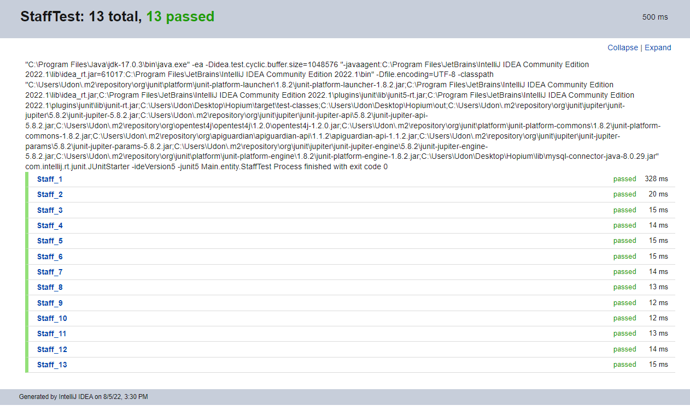**StaffTest**

|  |  |  |  |
| --- | --- | --- | --- |
| Test ID | Test Case | Expected Result | Actual Result |
| Staff_1 | Login with valid User Admin credentials | True | True |
| Staff_2 | Login with invalid User Admin credentials | False | False |
| Staff_3 | Login with valid User Admin but wrong profile | False | False |
|  | | | |
| Staff_4 | Login with valid Manager credentials | True | True |
| Staff_5 | Login with invalid Manager credentials | False | False |
| Staff_6 | Login with valid Manager but wrong profile | False | False |
|  |  |  |  |
| Staff_7 | Login with valid Staff credentials | True | True |
| Staff_8 | Login with invalid Staff credentials | False | False |
| Staff_9 | Login with valid Staff but wrong profile | False | False |
|  | | | |
| Staff_10 | Login with valid Owner credentials | True | True |
| Staff_11 | Login with invalid Owner credentials | False | False |
| Staff_12 | Login with valid Owner but wrong profile | False | False |
|  | | | |
| Staff_13 | Create database connection object | True | True |

Staff Class Junit 5 output

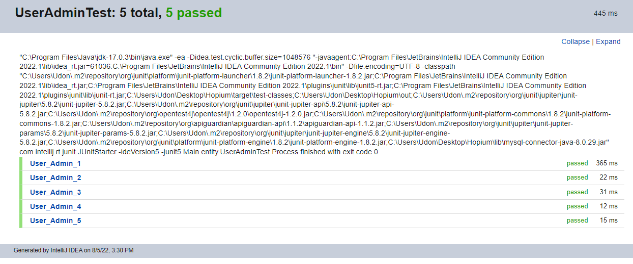**User_Admin**

|  |  |  |  |
| --- | --- | --- | --- |
| ID | Test Case | Expected Result | Actual  Result |
| User_Admin_1 | Create new account | True | True |
| User_Admin_2 | Edit an account | True | True |
| User_Admin_3 | Get information from database | True | True |
| User_Admin_4 | Search for accounts | True | True |
| User_Admin_5 | Suspend an account | True | True |

UserAdmin Class Junit 5 output

## Front End Testing

### Test Case Results and Screenshots

|  |  |
| --- | --- |
| **Test Case 3.2 – Create with existing credentials** | |
| **Steps** | 1. Login to User Admin account 2. Click the ‘Create’ button 3. Type in duplicate user account details 4. Click the ‘Create Account’ button |
| **Expected Results** | The program should show a window telling the user that the account already exists |
| **Actual Results** | The program should show a window telling the user that the account already exists |
| **Test Case 3.3 – Create with missing credentials** | |
| **Steps** | 1. Login to User Admin account 2. Click the ‘Create’ button 3. Type only username or password or neither 4. Click the ‘Create Account’ button |
| **Expected Results** | The program should show a window telling the user that fields should not be left empty |
| **Actual Results** | The program should show a window telling the user that fields should not be left empty |

#### User Story #3 and #8

|  |  |
| --- | --- |
| **Test Case 3.1 – Create with new credentials** | |
| **Steps** | 1. Login to User Admin account 2. Click the ‘Create’ button 3. Type in new user account details 4. Click the ‘Create Account’ button |
| **Expected Results** | The program should show a window telling the user a new account is created |
| **Actual Results** | The program should show a window telling the user a new account is created |

|  |  |
| --- | --- |
| Screenshots for User Story #3 and #8 | |
| Create page after ‘create’ button pressed | Message after new account created |
| Message when trying to create existing account | Message when trying to create with empty fields |

#### User Story #4 and #9

|  |  |
| --- | --- |
| **Test Case 4.1 – Edit User Account** | |
| **Steps** | 1. Login to User Admin account 2. Click ‘Edit’ button 3. Select a User Account 4. Modify the details in the fields 5. Click ‘Edit Changes’ button |
| **Expected Results** | The program should show a window telling the user that the edits are saved |
| **Actual Results** | The program should show a window telling the user that the edits are saved |
| **Test Case 4.2 – Edit details without selecting user** | |
| **Steps** | 1. Login to User Admin account 2. Click ‘Edit’ button 3. Modify the details without selecting user 4. Click ‘Edit Changes’ button |
| **Expected Results** | The program should warn the user that the account does not exist |
| **Actual Results** | The program should warn the user that the account does not exist |
| **Test Case 4.3 – Edit with empty fields** | |
| **Steps** | 1. Login to User Admin account 2. Click ‘Edit’ button 3. Select a User Account 4. Clear the username, password, user profile fields 5. Click ‘Edit Changes’ button |
| **Expected Results** | The program should warn the user that there are empty fields |
| **Actual Results** | The program should warn the user that there are empty fields |

|  |  |
| --- | --- |
| Screenshots for User Story #4 and #9 | |
| Edit page after ‘Edit’ button is pressed | Message after account is edited |
| Error message with empty fields | Error message when enter non-existent user details by not selecting user first |

#### User Story #5 and #10

|  |  |
| --- | --- |
| **Test Case 5.1 – Search for existing user by Username** | |
| **Steps** | 1. Login to User Admin account 2. Click ‘View’ button 3. Type an existing username 4. Click ‘Search by Username’ button |
| **Expected Results** | The program should show the list of user accounts that match the criteria |
| **Actual Results** | The program should show the list of user accounts that match the criteria |
| **Test Case 5.2 – Search for non-existent user by Username** | |
| **Steps** | 1. Login to User Admin account 2. Click ‘View’ button 3. Type a non-existing username 4. Click ‘Search by Username’ button |
| **Expected Results** | The program should show an empty list |
| **Actual Results** | The program should show an empty list |

|  |  |
| --- | --- |
| **Test Case 5.3 – Search for existing user by Username** | |
| **Steps** | 1. Login to User Admin account 2. Click ‘View’ button 3. Type an existing username 4. Click ‘Search by User Profile’ button |
| **Expected Results** | The program should show the list of user accounts that match the criteria |
| **Actual Results** | The program should show the list of user accounts that match the criteria |

|  |  |
| --- | --- |
| **Test Case 5.4 – Search for non-existent user by Username** | |
| **Steps** | 1. Login to User Admin account 2. Click ‘View’ button 3. Type a non-existing username 4. Click ‘Search by User Profile’ button |
| **Expected Results** | The program should show an empty list |
| **Actual Results** | The program should show an empty list |

|  |  |
| --- | --- |
| Screenshots for User Story #5 and #10 | |
| View page after ‘View’ button pressed | Search by Username result of ‘user2’ |
| Search by User Profile result of ‘Restaurant Staff’ | Searching non-existent username or user profile |

#### User Story #6 and #11

|  |  |
| --- | --- |
| **Test Case 6.1 – View all accounts** | |
| **Steps** | 1. Login to User Admin account 2. Click ‘View’ button |
| **Expected Results** | The program should show the list of user accounts |
| **Actual Results** | The program should show the list of user accounts |

|  |
| --- |
| Screenshots for User Story #6 and #11 |
| Clicking the ‘View’ button will show the list of all accounts |

#### User Story #7 and #12

|  |  |
| --- | --- |
| **Test Case 7.1 – Suspend user** | |
| **Steps** | 1. Login to User Admin account 2. Click ‘Suspend’ button 3. Select an active user 4. Click ‘Suspend/Un-suspend Account’ button |
| **Expected Results** | The program should show that the user account is suspended |
| **Actual Results** | The program should show that the user account is suspended |

|  |  |
| --- | --- |
| **Test Case 7.2 – Un-suspend user** | |
| **Steps** | 1. Login to User Admin account 2. Click ‘Suspend’ button 3. Select an inactive user 4. Click ‘Suspend/Un-suspend Account’ button |
| **Expected Results** | The program should show that the user account is un-suspended |
| **Actual Results** | The program should show that the user account is un-suspended |

|  |  |
| --- | --- |
| **Test Case 7.3 – Suspend/Un-suspend without selecting user** | |
| **Steps** | 1. Login to User Admin account 2. Click ‘Suspend’ button 3. Click ‘Suspend/Un-suspend Account’ button |
| **Expected Results** | The program should tell the user that no user is selected |
| **Actual Results** | The program should tell the user that no user is selected |

|  |  |
| --- | --- |
| Screenshots for User Story #7 and #12 | |
| Suspend page after ‘Suspend’ button is pressed | Message after account is suspended |
| Message after account is un-suspended | Message when no user is selected |
| Message after suspend by profile | Message after un-suspend by profile |

#### User Story #27

#### User Story #28

#### User Story #29

#### User Story #30

#### User Story #31

#### User Story #32

#### User Story #33

#### User Story #34